**Exploratory Data Analysis Insights**

In this phase of EDA, we will analyze the resultant table to gain insights into the distribution of each column. This will help us understand data patterns, identity anomalies, and ensure data quality before proceeding with further analysis.

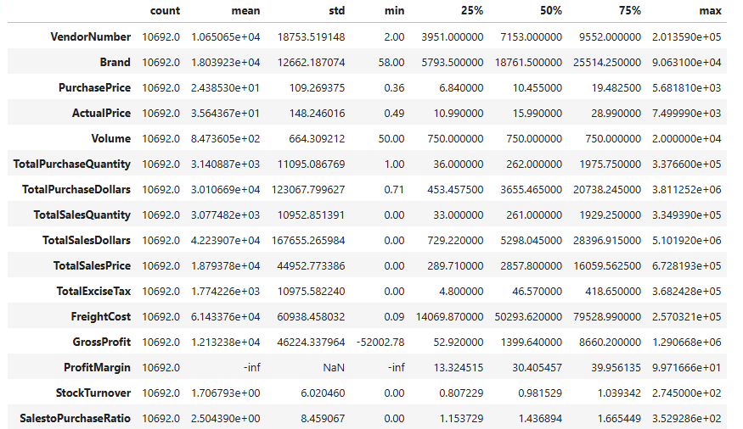**Summary Statistics**

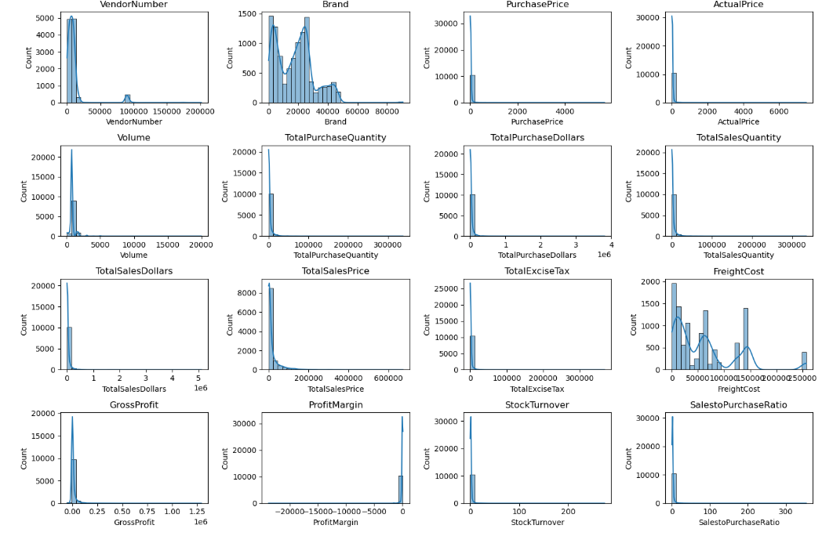

**Negative & Zero Values:**

* **Gross Profit**: Minimum value is -52,002.78, indicating losses. Some products or transactions may be selling at a loss due to high costs or selling at discounts lower than the purchase price.
* **Profit Margin**: Has a minimum of -∞, which suggests cases where revenue is zero or even lower than costs, leading to extreme lose in profit margins.
* **Total Sales Quantity & Sales Dollars**: Some products show zero sales, indicating they were purchased but never sold. These may be slow moving or obsolete stock, leading to inventory inefficiencies.

**Outliers Detected by High Standard Deviations:**

* **Purchase & Actual Prices**: The max values (5,681.81 & 7,499.99) are significantly higher than the mean (24.39 & 35.64), indicating potential premium products.
* **Freight Cost**: Huge variation, from 0.09 to 257,032.07, suggests logistics inefficiencies or bulk shipments.
* **Stock Turnover**: Ranges from 0 to 274.5, implying some products sell extremely fast while others remain in stock indefinitely. Value more than 1 indicates that sold quantity for that product is higher than purchased quantity due to either sales are being fulfilled from older stock.
* **Total Sales Quantity & Sales Dollars**: Minimum values are 0, meaning some products were purchased but never sold. These could be slow-moving or obsolete stock.

**Data Filtering**

To enhance the reliability of the insights, we removed inconsistent data points where:

* Gross Profit ≤ 0 (to exclude transactions leading to losses).
* Profit Margin ≤ 0 (to ensure analysis focuses on profitable transactions).
* Total Sales Quantity = 0 (to eliminate inventory that was never sold).

**Correlation Insights**

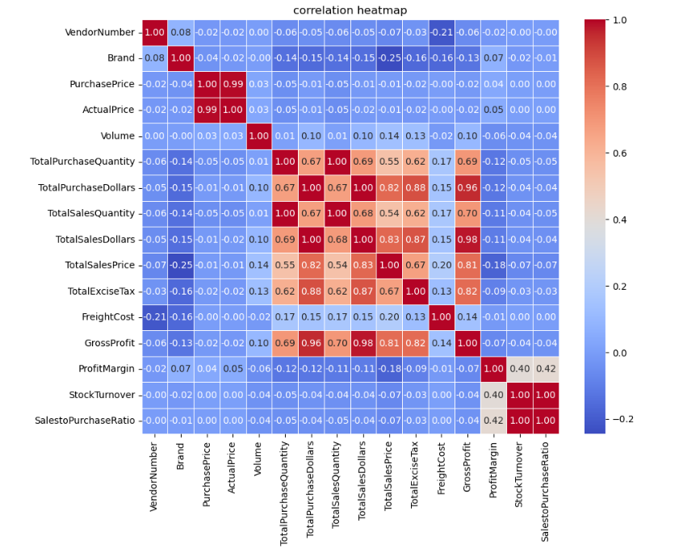

* PurchasePrice has weak correlations with TotalSalesDollars (-0.012) and GrossProfit (-0.016), suggesting that price variations do not significantly impact sales revenue or profit.
* Strong correlation between total purchase quantity and total sales quantity (1.0), confirming efficient inventory turnover.
* Negative correlation between profit margin & total sales price (-0.18) suggests that as sales price increases, margins decrease, possibly due to competitive pricing pressures.
* StockTurnover has weak negative correlations with both GrossProfit (-0.038) and ProfitMargin (-0.055),indicating that faster turnover does not necessarily result in higher profitability.

**1. Strong Positive Correlations**

* PurchasePrice & ActualPrice (0.99)**:** These two are almost identical, suggesting accurate price tracking.
* TotalPurchaseQuantity, TotalSalesQuantity & TotalPurchaseDollars (0.67–1.00): Indicates that purchase and sales quantities are tightly aligned, confirming efficient stock movement.
* TotalSalesDollars, TotalSalesPrice, and GrossProfit (0.69–0.98): Strong positive relationship shows that higher sales values directly contribute to profit growth.
* TotalExciseTax & Sales Values (0.82–0.88): Higher sales naturally lead to higher taxes collected.

**2. Moderate Correlations**

* ProfitMargin with GrossProfit (0.82): Suggests that higher gross profits generally lead to better margins, but not always due to pricing/discounting strategies.
* Sales-to-Purchase Ratio with ProfitMargin (0.42): Efficient conversion of purchases to sales is linked to higher profitability.
* StockTurnover & ProfitMargin (0.40): Faster inventory turnover tends to improve margins, but correlation is not very strong.

**3. Weak or Negligible Correlations**

* PurchasePrice with TotalSalesDollars (-0.01) and GrossProfit (-0.02): Implies that variations in purchase price don’t strongly impact revenue or profit.
* VendorNumber and Brand with Financial Metrics (mostly <0.1): Vendor and brand identity have minimal direct correlation with profitability or sales.

**4. Negative Correlations**

* ProfitMargin & TotalSalesPrice (-0.12 to -0.18): Suggests that as sales price increases, profit margin can drop—likely due to competitive discounting or rising costs.
* FreightCost with Profitability (-0.11 with GrossProfit, -0.18 with ProfitMargin): Higher logistics costs negatively affect overall profit.

**Key Takeaways ✅:**

* Sales quantity and purchase quantity move in sync, showing healthy stock turnover.
* GrossProfit is most strongly driven by TotalSalesDollars and TotalSalesPrice.
* Freight cost remains a weak but notable drag on profitability.
* Margins are sensitive to sales price increases, possibly due to discounts or competition.

**Research Questions and Findings**

1. 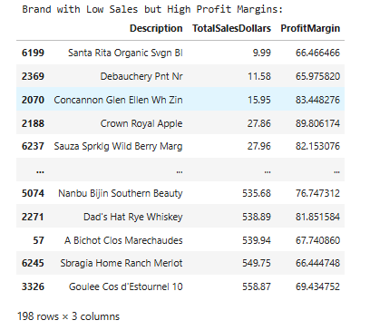**Brands for Promotional or Pricing Adjustments**

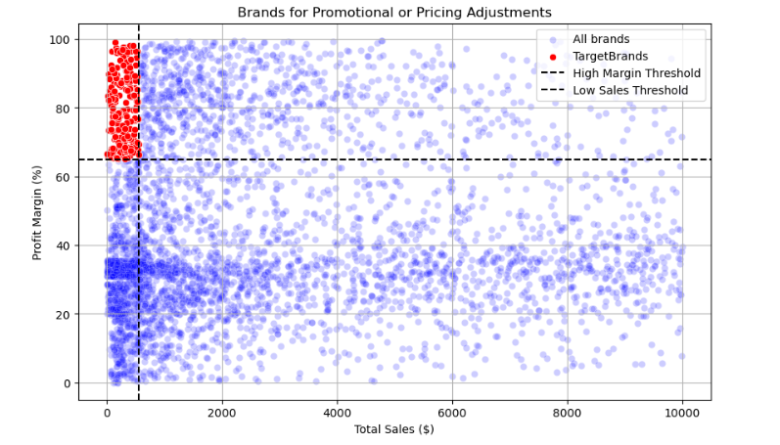198 brands exhibit lower sales but higher profit margins, which could benefit form targeted marketing, promotions, or price optimizations to increase volume without compromising profitability.

1. **Top Vendors by Sales & Purchase Contribution**

The top 10 Vendors contribute 65.69% of total purchases, while the remaining vendors contribute only 34.31%. This over-reliance on a few vendors may introduce risks such as supply chain disruptions, indicating a need for diversification.

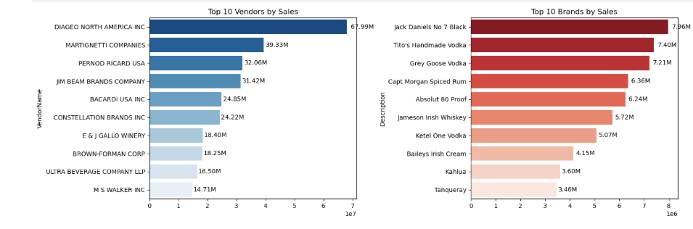Top Vendors and Brands by Sales

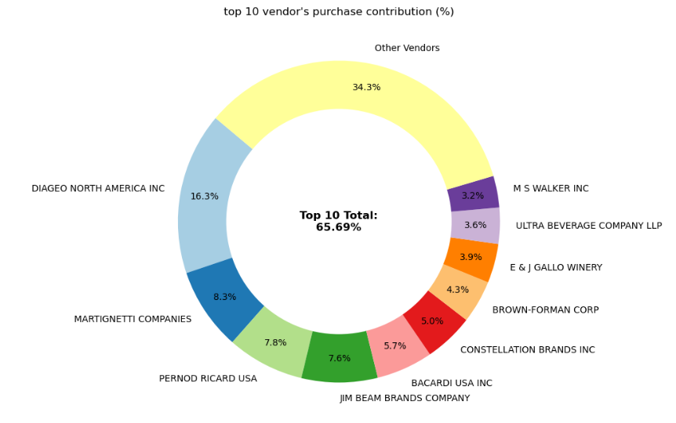

**3. Impact of Bulk Purchasing on Cost Savings**

Vendors buying in large quantities receive a 72% lower unit cost ($10.78 per unit vs. higher unit costs in smaller orders).

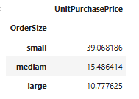Bulk pricing strategies encourage larger orders, increasing total sales while maintaining profitability.

**4. Identifying Vendors with Low Inventory Turnover**

Total Unsold Inventory Capital: $2.71M

Slow moving inventory increases storage costs, reduces cash flow efficiency, and affects overall profitability.

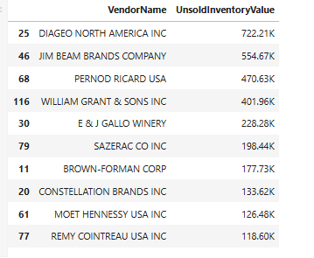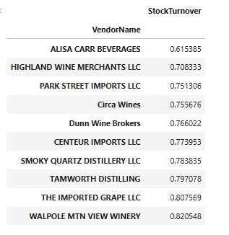Identifying vendors with low inventory turnover enables better stock management, minimizing financial strain.

**5.Profit Margin Comparison:**

Top Vendors' Profit Margin (95% CI): (30.74%, 31.61%), Mean: 31.17% Low Vendors' Profit Margin (95% CI): (40.48%, 42.62%), Mean: 41.55%

Low-performing vendors maintain higher margins but struggle with sales volumes, indicating potential pricing inefficiencies or market reach issues.

Actionable Insights:

Top-performing vendors: Optimize profitability by adjusting pricing, reducing operational costs, or offering bundled promotions.

Low-performing vendors: Improve marketing efforts, optimize pricing strategies, and enhance distribution networks.

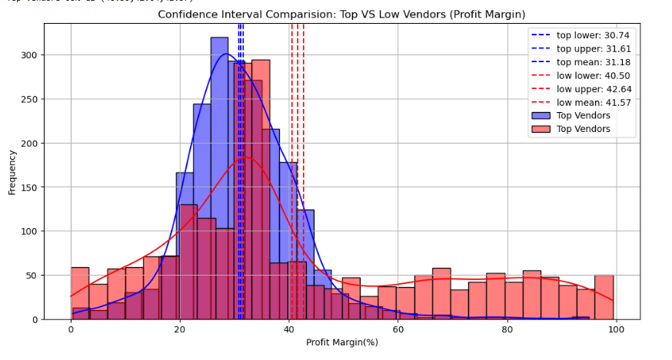

* The confidence interval for low-performing vendors (40.48% to 42.62%) is significantly higher than that of top-performing vendors (30.74% to 31.61%).
* This suggests that vendors with lower sales tend to maintain higher profit margins, potentially due to premium pricing or lower operational costs.
* For High-Performing Vendors: If they aim to improve profitability, they could explore selective price adjustments, cost optimization, or bundling strategies.
* For Low-Performing Vendors: Despite higher margins, their low sales volume might indicate a need for better marketing, competitive pricing, or improved distribution strategies.

**6. Statistical Validation of Profit Margin Differences**

**Hypothesis Testing:**

* (Null Hypothesis): No significant difference in profit margins between top and low-performing vendors.
* (Alternative Hypothesis): A significant difference exists in profit margins between the two vendor groups.

**Result:** The null hypothesis is **rejected**, confirming that the two groups operate under distinctly different profitability models.

**Implication:** High-margin vendors may benefit from better pricing strategies, while top-selling vendors could focus on cost efficiency.

**Final Recommendations**

* Re-evaluate pricing for low-sales, high margin brands to boost sales volume without sacrificing profitability.
* Diversify vendor partnerships to reduce dependency on a few suppliers and mitigate supply chain risks.
* Leverage bulk purchasing advantages to maintain competitive pricing while optimizing inventory management.
* Optimize slow-moving inventory by adjusting purchase quantities, launching clearance sales, or revising storage strategies.
* Enhance marketing and distribution strategies for low-performing vendors to drive higher sales volumes without compromising profit margins.
* By implementing these recommendations, the company can achieve sustainable profitability**,** mitigate risks, and enhance overall operational efficiency.

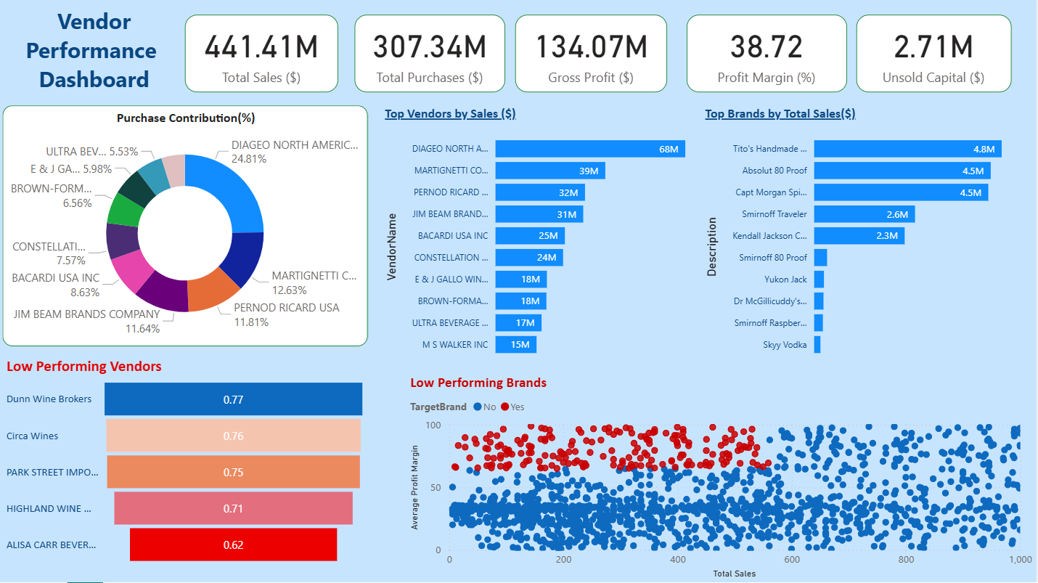**Vendor Performance Analysis Report( Based on PowerBi Dashboard)**

**Objective**: To analyze key financial metrics, vendor contributions, and identify areas of low performance within the vendor and brand portfolio.

**1. Executive Summary**

The overall vendor performance indicates strong total sales and healthy profitability. Total Sales reached $441.41M, resulting in a Gross Profit of $134.07M, yielding a solid Profit Margin of 38.72%. However, the dashboard also highlights $2.71M in Unsold Capital, indicating potential inventory issues that need investigation. Vendor performance is highly concentrated, with the top vendor contributing nearly a quarter of all purchases. Attention must be focused on the identified low-performing vendors and brands to mitigate risks and improve portfolio health.

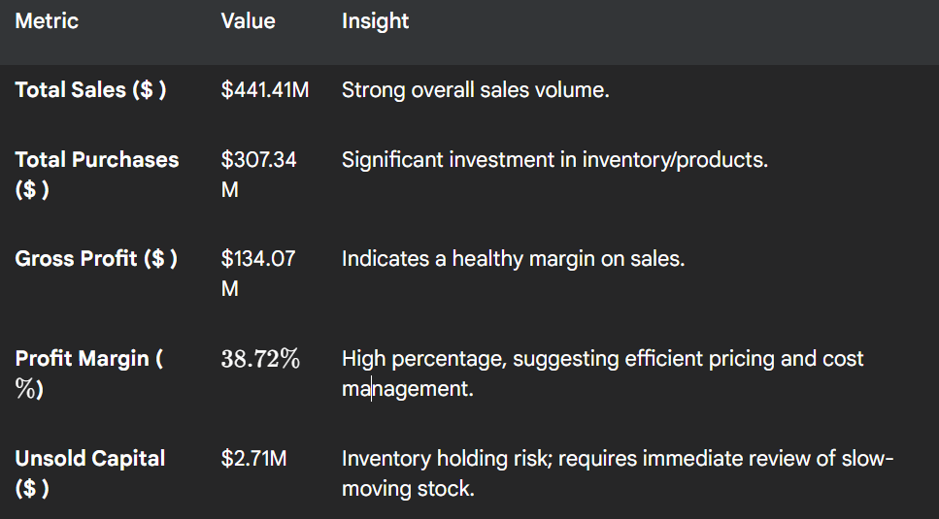**2. Key Financial Metrics**

**3. Vendor Sales and Contribution Analysis**

**A. Purchase Contribution (%)**

Purchase contribution is heavily skewed towards the top three vendors, indicating concentration risk.

These top five vendors account for approximately 69.52% of the total purchase volume.

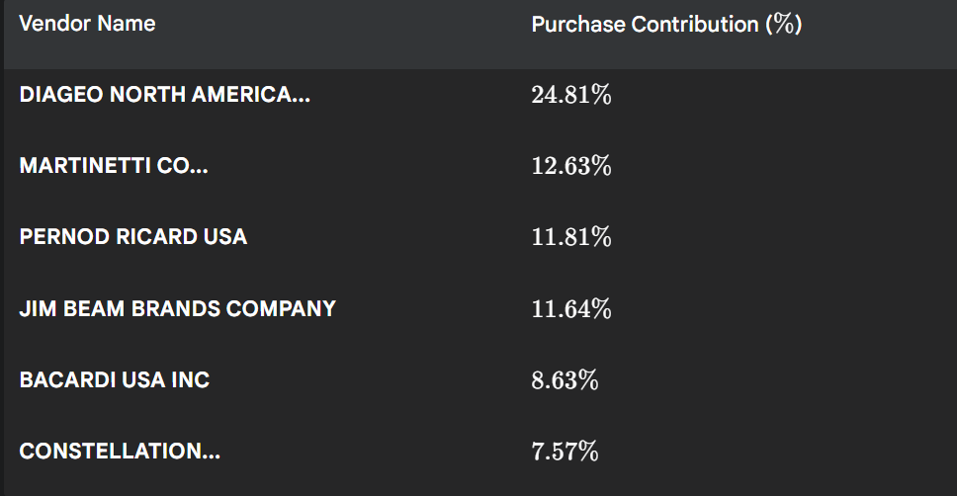**B. Top Vendors by Sales ($)**

The top vendors driving the highest absolute sales volumes are:

1. DIAGEO NORTH AMERICA...: $68
2. MARTINETTI CO...: $39M
3. PERNOD RICARD USA: $32M
4. JIM BEAM BRANDS COMPANY: $31M
5. BACARDI USA INC: $25M

**C. Top Brands by Total Sales ($)**

The top-performing brands indicate consumer preferences and key revenue drivers:

1. Tito's Handmade: $4.8M
2. Absolut 80 Proof: $4.5M
3. Capt Morgan Sp: $4.5M
4. Smirnoff Traveler: $2.6M
5. Kendall Jackson C...: $2.3M

**4. Low Performance Identification**

**A. Low Performing Vendors**

The five lowest performing vendors, measured by a performance score (likely related to profitability, fulfilment, or score below 1.0), require immediate performance improvement plans.

1. Dunn Wine Brokers: 0.77
2. Circa Wines: 0.76
3. PARK STREET IMPO...: 0.75
4. HIGHLAND WINE...: 0.71
5. ALISA CARR BEVER...: 0.62

**Recommendation**: Engage with these vendors to understand the root cause of the low score. For the lowest scorer, ALISA CARR BEVER... (0.62), consider contract review or discontinuation if performance does not improve.

**B. Low Performing Brands (TargetBrand = No)**

* The scatter plot (Average Profit Margin vs. Total Sales) identifies brands that are not flagged as "Target Brands" (red dots). These brands represent products with low sales volumes and/or below-average profit margins.
* A large cluster of non-Target Brands (Blue Dots) exists in the lower left quadrant, indicating many products with low Total Sales (below $200K) and widely varying, sometimes low, Average Profit Margins (below 50%).
* The brands flagged as Target Brand = No (blue dots) are numerous and dilute the overall profit efficiency.

**Recommendation**: Apply the "low performing brand" strategy: either increase sales volume for low-margin products, or increase the margin for low-volume products, or prune brands that fall into the lowest sales/margin category.

**5. Conclusion and Next Steps**

* The business is financially sound with high sales and margin. The primary focus for improvement should be on optimizing the tail end of the portfolio:
* Unsold Capital Review: Immediately analyze the $2.71M in Unsold Capital to determine the age and specific SKUs contributing to this value.
* Vendor Development: Initiate performance review meetings with the 5 lowest performing vendors, starting with ALISA CARR BEVER...
* Brand Rationalization: Develop a process for rationalizing the large number of low-volume/low-margin brands (Blue Dots) to free up capital and warehouse space.